Independent Clause

🔤 Definition:
# Source: AI Source: Provided by: [Data Path: Persons Table -> ID Column: 1, Name_En Column: Motasem Essam] -> From: [Chatgpt (GPT-4-turbo)] on [7/29/2025]
An independent clause is a group of words that contains a subject and a predicate (verb), and expresses a complete thought.
It can stand alone as a simple sentence, or be combined with other clauses to form compound or complex sentences.

🧩 Structure of an Independent Clause:
# Source: AI Source: Provided by: [Data Path: Persons Table -> ID Column: 1, Name_En Column: Motasem Essam] -> From: [Chatgpt (GPT-4-turbo)] on [7/29/2025]
Subject + Verb [+ Object or Complement]
Examples:
- She sings.
- The students are studying.
- We will go to the beach tomorrow.

✏️ Examples in Sentences:
# Source: AI Source: Provided by: [Data Path: Persons Table -> ID Column: 1, Name_En Column: Motasem Essam] -> From: [Chatgpt (GPT-4-turbo)] on [7/29/2025]
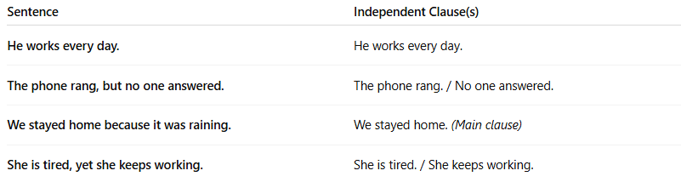

Sentence | Independent Clause(s)
He works every day. | He works every day.
The phone rang, but no one answered. | The phone rang. / No one answered.
We stayed home because it was raining. | We stayed home. (Main clause)
She is tired, yet she keeps working. | She is tired. / She keeps working.

🔄 Independent Clauses in Sentence Types:
# Source: AI Source: Provided by: [Data Path: Persons Table -> ID Column: 1, Name_En Column: Motasem Essam] -> From: [Chatgpt (GPT-4-turbo)] on [7/29/2025]
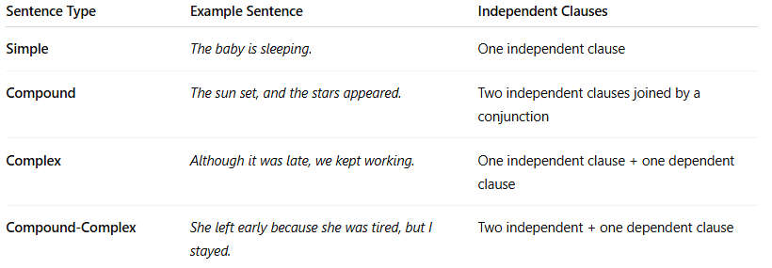
Sentence Type | Example Sentence | Independent Clauses
Simple | The baby is sleeping. | One independent clause
Compound | The sun set, and the stars appeared. | Two independent clauses joined by a conjunction
Complex | Although it was late, we kept working. | One independent clause + one dependent clause
Compound-Complex | She left early because she was tired, but I stayed. | Two independent + one dependent clause

🧠 Tips to Identify an Independent Clause:
# Source: AI Source: Provided by: [Data Path: Persons Table -> ID Column: 1, Name_En Column: Motasem Essam] -> From: [Chatgpt (GPT-4-turbo)] on [7/29/2025]
✅ It has a subject and a verb
✅ It makes complete sense by itself
✅ It can stand alone as a full sentence

🧠 Quick Practice: Which are independent clauses?
# Source: AI Source: Provided by: [Data Path: Persons Table -> ID Column: 1, Name_En Column: Motasem Essam] -> From: [Chatgpt (GPT-4-turbo)] on [7/29/2025]
- ❓ Because the car broke down
- ✅ He fixed the tire
- ✅ They went shopping
- ❓ When I arrived at school
Answers:
✅ 2 & 3 are independent clauses.
❌ 1 & 4 are dependent (they don’t form a full idea alone).

